

American International University-Bangladesh (AIUB)  
**Department of Computer Science  
Faculty of Science & Technology (FST)**

**PROJECT TITLE**

**Augmented Reality software for interior Design**

A Software Engineering Project Submitted

By

|  |  |  |  |  |
| --- | --- | --- | --- | --- |
| **Semester: Spring_22_23** | | **Section:** | **Group Number:** | |
| SN | Student Name | Student ID | Contribution (CO1+CO3) | Individual Marks |
| 1. | MD. ZAMIUL SADIK NAHIN | 20-44228-3 | 25 |  |
| 2. | ABDULLA AL NOMAN | 21-44573-1 | 25 |  |
| 3. | MOHAMMAD BIN HARUN | 21-44583-1 | 25 |  |
| 4. | RIDWAN AHMED ARMAN | 21-44504-1 | 25 |  |

**PROJECT PROPOSAL**

* **Write the background description that helps putting your project into the right context of a problem domain and gives everyone involved a common view of the project.**

The suggested project intends to create an Augmented Reality (AR) software program that is specifically made for applications in interior design. Users using the software will be able to see and interact in real time with digital versions of furniture, decorations, and room layouts, which will help them make wise design choices and develop engaging experiences.

Interior design is a complex and multi-faceted process that requires careful consideration of many factors, such as furniture arrangement, lighting, color schemes, and textures. Traditional interior design methods, such as 2D sketches and physical mock-ups, can be time-consuming and costly, and often result in miscommunication and dissatisfaction between designers and clients. This project aims to improve the creative process and increase the level of collaboration and satisfaction between designers and clients.

* **What is the root cause of this problem? Why is this problem is so important to consider?**

1. **Personalization and Customization**:

Individual interests and styles must be considered while designing an interior. Augmented Reality software enables users to customize materials, colors, and styles in real time, resulting in a more personalized experience. This enables customers to investigate many design alternatives, experiment with various variables, and find the ideal mix that meets their preferences.

1. **Costly Mistakes:**

Traditional interior design approaches frequently entail acquiring furniture or decor items based on intuition or 2D renderings, which can lead to costly blunders if they do not fit or compliment the area. Users can preview how different things would look in their location using Augmented Reality software, ensuring better decision-making and lowering the possibility of costly errors.

1. **Showcasing and Marketing:**

Interior designers and furniture sellers must successfully showcase their designs or products in order to attract clients or customers. Augmented Reality software may generate visually attractive presentations that mimic real-life experiences, making it easier to exhibit design concepts or promote furniture products. This improves marketing efforts and assists clients in making educated judgments.

* **What is your project objective?**

The project's goal is to develop an efficient and effective solution for interior design visualization that addresses the constraints and limits of existing interior design approaches. The initiative intends to improve the creative process, promote teamwork and client happiness, and reduce the chance of costly mistakes.

1. Create an intuitive and user-friendly augmented reality application for interior design.
2. Allow users to virtually position and adjust furniture and decor objects in their physical space.
3. Include interactive elements for customizing materials, colors, and styles

* **What solution are you going to provide to solve the above-mentioned problem.**

**Real-time visualization**: The app makes use of AR technology to allow users to arrange objects in real time. real-time interaction with virtual objects in their actual environment offering a realistic portrayal of how the interior design will look and feel.

**Customization options**: The software has a library of pre-made objects as well as the ability to import bespoke 3D models, making it simple for designers and clients to bring their vision to life.

**Improved collaboration**: The real-time visualization and customization options provided by the software make it easier for designers and clients to work together, eliminating the risk of miscommunication and increasing satisfaction with the final result.

* **Who are the target group of users of your solution? And how they will be benefited by your proposed solution to the problem?**

The target group of users for the AR-based interior designing software solution includes interior designers, architects, homeowners. These users will benefit from the solution in the following ways:

**Interior designers:** The program gives interior designers a tremendous tool for bringing their concept to life and presenting it to clients in a very interactive and engaging way. This improves the design process and the designer's ability to win projects and retain clients.

**Architects:** Using the program, architects may understand the impact of their design choices on the actual environment and make informed decisions that improve the functionality and beauty of the interior design. This improves efficiency while lowering the likelihood of costly errors.

**Homeowners:** Using the software, homeowners may visualize their interior design ideas and make informed judgments regarding the look and feel of their living spaces. This improves the homeowner's capacity to customize their living areas and their general pleasure with the outcome.

* **What are the basic functionalities of your proposed solution?**

1. Software Login
2. Software signup
3. Home panel
4. Searching
5. Camera scan
6. Wishlist
7. Shopping cart
8. Side navigation bar
9. Notification panel
10. Settings panel
11. Confirm purchase
12. Log out

**Selection of Process Model**

* **Study the Software Engineering process model to appropriate process model to develop your proposed system solution.**

The process model we chose is the incremental model, which is a good way for producing this type of software because it includes developing and releasing it in stages. This facilitates early feedback from stakeholders and customers, which is especially crucial in a software development project involving user experience and design. The gradual approach also provides for more adaptability to changing requirements and technologies, which is critical in a quickly growing industry like augmented reality.

* **Present your arguments based on your analysis about why your selected method(s) is the best choice among all other methods to develop your proposed software.**

For this project, we used a plan-driven approach. We could have picked agile process models instead, but we didn't because we knew exactly what we needed for this project. Furthermore, because our environment is steady, plan-driven processes will outperform agile process models. Because this augmented reality-based interior design software is highly essential, we chose plan-driven process modeling over agile because agile is improper for safety-critical software.

1. Because the software is complicated, the incremental methodology allows for testing and validation at each level. This ensures that each stage has been completely tested and approved before proceeding to the next.
2. The incremental model enables ongoing feedback and improvement during the development process, which is necessary for the software, which necessitates regular communication and engagement with the end users.
3. The incremental model is adaptive and flexible, which is crucial for a software project like this one that could need to evolve in response to customer input, technology developments, or market trends.

**Requirement Analysis**

* **Functional Requirements**

1. **Software Login Functional Requirements**
   1. The software shall allow users to login with their given username and password.
   2. The login credentials (username and password) will be verified with database records.
   3. If the login is successful, the home page of the user account will be displayed.
   4. If the username and/or password has been inserted wrong, the user can retry five more times.
   5. If the number of login attempts exceeds the system's limit, the user account login will be blocked for thirty seconds.
   6. Users can utilize the "Forgot password" function to request a verification code, which will be sent to the specified phone number or email address, if they have forgotten their password. whereby they can modify their password.
2. **Software Signup Functional Requirements**
   1. Users must enter their Full Name, Date of Birth, Gender, Phone Number, Address, Email, Username, and Password in order to establish a new account on the software.
   2. The system will examine the database records to determine if the Username is distinct or not. Usernames that are already in use won't be allowed for registration.
   3. A password must have at least 8 characters in order to be considered legitimate.
   4. Following successful account creation, the database will have all of the data.

Priority Level: High

Precondition: User has valid phone number and email.

1. **Home Panel Functional Requirements**
   1. Allows users to navigate to the home page from any page.

Priority Level: Medium

Precondition: User must be logged in.

1. **Searching Functional Requirements**
   1. Enables users to look for any kind of merchandise.
   2. Users will be able to narrow down their searches based on price, product category, available products, and location using the filtering tool.
   3. Search results can also be sorted by users.
   4. Users can see their past search histories as well.

Priority Level: Medium.

Precondition: User must be logged in

1. **Camera Scan Functional Requirements**
   1. Will request the user's consent to access the camera and storage.
   2. Users will have the option of scanning in real time or using previously shot photos that are stored on their devices.
   3. A search bar and a list of available products will be located on the side of the screen.
   4. Users can drag and drop any desired products into the processed Augmented Reality environment from the list.
   5. The software will enable customers to alter the product's size and color, seek for comparable items, and add the item to their Wishlist.

Priority Level: High.

Precondition: User must allow camera and storage access.

1. **Wishlist Panel Functional Requirements**
   1. The items that users add to their Wishlist will be listed in this panel.
   2. Users can access all of the product's specific information by clicking on a certain item.
   3. Users will be able to take a product off their Wishlist using the software.

Priority Level: Medium

Precondition: User must be logged in.

1. **Shopping Cart Functional Requirements**
   1. A list of all the items customers will add to their basket will be displayed in this panel.
   2. Users can access all of the product's specific information by clicking on a certain item.
   3. The software will enable customers to modify the quantity of a product and delete items from the shopping cart.
   4. Users can finalize their purchase by clicking a button that directs them to the panel for processing purchases.

Priority Level: High

Precondition: User must be logged in.

1. **Side Navigation Bar Functional Requirements**
   1. In the home panel, there will be a side navigation icon that will contain a variety of options including the user's profile name, home, Wishlist, notification, purchase history, settings, support, and logout.

Priority Level: Medium.

Precondition: User must be logged in.

1. **Notification Panel Functional Requirements**
   1. Notifications about sale offers, order status, and other announcements will be sent to the user.
   2. The notice can be taken off the user's list of notifications.

Priority Level: Medium

Precondition: User must be logged in.

1. **Settings Panel Functional Requirements**

10.1 The software will allow users to change the language or switch to dark mode and revert.

10.2 The users will be able to change their provided information.

10.3 The users will be able to change their password by verifying their old password.

Priority Level: Medium

Precondition: User has to be logged in.

**System Design Specification**

* **Use Case diagram.**

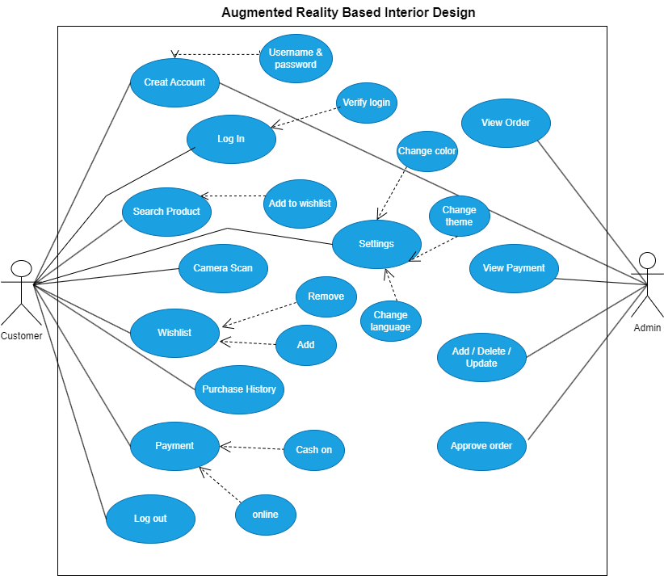

* **Class Diagram:**

* **Activity diagram:**

* **Sequence Diagram**

**UI / UX Design**

* Sign In Page

* Sign Up page.

* Side Navigation Bar

* Camera Scan

**TEST CASE:**

|  |  |  |  |  |  |
| --- | --- | --- | --- | --- | --- |
| Project Name: AR based interior decorating software. | | | Test Designed by: | | |
| Test Case ID: FR_1-1 | | | Test Designed date: 17/7/2023 | | |
| Test Priority (Low, Medium, High): Medium | | | Test Executed by: | | |
| Module Name: Login Session | | | Test Execution date: | | |
| Test Title: Verify login with valid username and password | | | | | |
| Description: Test application login page. | | | | | |
| Precondition (If any): User must have valid username and password. | | | | | |
| Test Steps | Test Data | Expected Results | | Actual Results | Status (Pass/Fail) |
| 1. Open application 2. Enter username. 3. Enter password. 4. Click submit | Username:  Pheonix10  Password: 3211 | User should login into the application | | As expected | Pass |
| Post Condition: User is validated with database and successfully login to account. The account session details are logged in the database. | | | | | |

|  |  |  |  |  |  |
| --- | --- | --- | --- | --- | --- |
| Project Name: AR based interior decorating software. | | | Test Designed by: | | |
| Test Case ID: FR_1-2 | | | Test Designed date: 24/7/2023 | | |
| Test Priority (Low, Medium, High): Medium | | | Test Executed by: | | |
| Module Name: Login Session | | | Test Execution date: | | |
| Test Title: verify login with invalid username and password | | | | | |
| Description: Test application login page | | | | | |
| Precondition (If any): User must have valid username and password | | | | | |
| Test Steps | Test Data | Expected Results | | Actual Results | Status (Pass/Fail) |
| 1. Open application 2. Enter an invalid username. 3. Enter an invalid password. 4. Click submit | Username: Pheonix10 Password: | User should not login into the application | | As expected | Pass |
| Post Condition: User is not validated with database and cannot login to the account. An error message is displayed on the screen. | | | | | |

|  |  |  |  |  |  |
| --- | --- | --- | --- | --- | --- |
| Project Name: AR based interior decorating software. | | | Test Designed by: | | |
| Test Case ID: FR_2-1 | | | Test Designed date: 24/7/2023 | | |
| Test Priority (Low, Medium, High): Medium | | | Test Executed by: | | |
| Module Name: Signup Session | | | Test Execution date: | | |
| Test Title: verify provided information and save to database | | | | | |
| Description: Test application signup page | | | | | |
| Precondition (If any): User must have valid email or phone number | | | | | |
| Test Steps | Test Data | Expected Results | | Actual Results | Status (Pass/Fail) |
| 1. Open application 2. Click on Signup 3. Enter Full Name, DoB, Gender, Phone Number, Address, Email, Username and Password 4. Click register | Full Name: Gabe DoB: 27-11- 2000. Gender: Male Phone Number: 01883945023 Address: Kazi Street Email: gabe11@gmail.c co Username: gabe1017 Password: 1234 | User should signup into the application | | As expected | Pass |
| Post Condition: The user's registration information is validated and stored in the database, allowing the user to log in to the application with their newly created account. | | | | | |

|  |  |  |  |  |  |
| --- | --- | --- | --- | --- | --- |
| Project Name: AR based interior decorating software. | | | Test Designed by: Abdulla Al Noman | | |
| Test Case ID: FR_2-2 | | | Test Designed date: 17/7/2023 | | |
| Test Priority (Low, Medium, High): Medium | | | Test Executed by: | | |
| Module Name: Signup Session | | | Test Execution date: | | |
| Test Title: verify provided information and save to database | | | | | |
| Description: Test application signup page | | | | | |
| Precondition (If any): User must have valid email or phone number | | | | | |
| Test Steps | Test Data | Expected Results | | Actual Results | Status (Pass/Fail) |
| 1. Open application 2. Click on Signup 3. Enter Full Name, DoB, Gender, Phone Number, Address, Email, Username and Password 4. Click register | Full Name: Gabe  DoB: 27-11-2000.  Gender: Male Phone Number: 8888888  Address: Kazi Street  Email: gabe11@gmail.ccoUsername: gabe2Password: 12334 | User should signup into the application due to invalid phone number | | As expected, | Pass |
| Post Condition: User is not registered, and an error message is displayed on the screen. | | | | | |

|  |  |  |  |  |  |
| --- | --- | --- | --- | --- | --- |
| Project Name: AR based interior decorating software. | | | Test Designed by: Abdulla Al Noman | | |
| Test Case ID: FR_3 | | | Test Designed date: 17/7/2023 | | |
| Test Priority (Low, Medium, High): Medium | | | Test Executed by: | | |
| Module Name: Logout Session | | | Test Execution date: | | |
| Test Title: verify user can successfully logout | | | | | |
| Description: Test application logout functionality | | | | | |
| Precondition (If any): User must be logged in | | | | | |
| Test Steps | Test Data | Expected Results | | Actual Results | Status (Pass/Fail) |
| 1. Click on logout button. 2. Verify if user is redirected to the login page. | N/A | User should be redirected to the login page after logging out. | | As expected, | Pass |
| Post Condition: User is redirected to the homepage or login page. Any unsaved data or changes made by the user during the session are saved if applicable. The user's account details are logged out from the database. | | | | | |

|  |  |  |  |  |  |
| --- | --- | --- | --- | --- | --- |
| Project Name: AR based interior decorating software. | | | Test Designed by: Mohammad Bin Harun | | |
| Test Case ID: FR_4 | | | Test Designed date: 17/7/2023 | | |
| Test Priority (Low, Medium, High): | | | Test Executed by: | | |
| Module Name: Confirm Purchase | | | Test Execution date: | | |
| Test Title: Confirm Purchase with Valid Details | | | | | |
| Description: Test the functionality of confirming a purchase with valid details | | | | | |
| Precondition (If any): User must have items in the cart and be logged in | | | | | |
| Test Steps | Test Data | Expected Results | | Actual Results | Status (Pass/Fail) |
| 1. Log in to the application. 2. Add items to the cart. 3. Click on the cart icon to view the items in the cart. 4. Click on the checkout button. 5. Enter valid shipping address. 6. Select payment method. 7. Enter valid payment details. 8. Click on the confirm purchase button. | Test Data:  Shipping Address:123 Main StAnytown, USA  Zip Code: 12345  Payment Method: Visa  Card Number: 4111 1111 1111 1111  Expiration Date: 12/23  CVV: 123 | User should be able to click on the confirm purchase button and the purchase should be successful. | |  |  |
| Post Condition: The order is confirmed, and the purchase details are stored in the database. The purchased item(s) are deducted from the inventory and the payment is processed successfully | | | | | |

|  |  |  |  |  |  |
| --- | --- | --- | --- | --- | --- |
| Project Name: AR based interior decorating software. | | | Test Designed by: Mohammad Bin Harun | | |
| Test Case ID: FR_5 | | | Test Designed date: 17/7/2023 | | |
| Test Priority (Low, Medium, High): | | | Test Executed by: | | |
| Module Name: Confirm Purchase | | | Test Execution date: | | |
| Test Title: Verify error message on confirmation with invalid data | | | | | |
| Description: Test the Confirm Purchase functionality with invalid data | | | | | |
| Precondition (If any): User must be on the Confirm Purchase page | | | | | |
| Test Steps | Test Data | Expected Results | | Actual Results | Status (Pass/Fail) |
| 1. Enter invalid card number. 2. Enter invalid expiration date. 3. Enter invalid CVV. 4. Click on the "Confirm Purchase" button | Card  Number:  12345678901  2345 (invalid  card number)  Expiration  Date: 13/24  (invalid  expiration  date)  CVV: 12  (invalid CVV) | User should not be able to confirm the purchase and remain on the Confirm Purchase page. | | As expected, | Pass |
| Post Condition: The order is not confirmed, and an error message is displayed to the user. The purchase details are not stored in the database and the inventory is not updated. The payment is not processed. | | | | | |

|  |  |  |  |  |  |
| --- | --- | --- | --- | --- | --- |
| Project Name: AR based interior decorating software. | | | Test Designed by: Mohammad Bin Harun | | |
| Test Case ID: FR_6 | | | Test Designed date: 17/7/2023 | | |
| Test Priority (Low, Medium, High): Medium | | | Test Executed by: | | |
| Module Name: Add to Wishlist | | | Test Execution date: | | |
| Test Title: Verify adding a product to the Wishlist | | | | | |
| Description: Test adding a product to the Wishlist panel | | | | | |
| Precondition (If any): User must be logged in and have access to the Wishlist panel | | | | | |
| Test Steps | Test Data | Expected Results | | Actual Results | Status (Pass/Fail) |
| 1. Open the application. 2. Navigate to the product page. 3. Click on the "Add to Wishlist" button. 4. Verify that the product is added to the Wishlist panel. 5. Navigate to the Wishlist panel. 6. Verify that the added product is displayed in the Wishlist panel | Product Name: "Wood Chair" Product ID: 445 | The added product should be displayed in the Wishlist panel without any errors. | | As expected, | Pass |
| Post Condition: The product is successfully added to the user's Wishlist, and the system updates the user's account with the latest Wishlist information. The user can access the added product in their Wishlist at any time during their active session on the application. | | | | | |

|  |  |  |  |  |  |
| --- | --- | --- | --- | --- | --- |
| Project Name: AR based interior decorating software. | | | Test Designed by: Mohammad Bin Harun | | |
| Test Case ID: FR_7 | | | Test Designed date: 17/7/2023 | | |
| Test Priority (Low, Medium, High): Medium | | | Test Executed by: | | |
| Module Name: Notification Panel | | | Test Execution date: | | |
| Test Title: Verify new notifications appear in the notification panel | | | | | |
| Description: Test the functionality of the notification panel that displays new notifications for the user. | | | | | |
| Precondition (If any): The user must be logged in to the application. | | | | | |
| Test Steps | Test Data | Expected Results | | Actual Results | Status (Pass/Fail) |
| 1. Open the application and log in with valid credentials. 2. Check if the notification panel is empty. 3. Trigger a notification, e.g., receive a message, friend request, or like on a post. 4. Check if the notification appears in the notification panel. 5. Click on the notification to view its details. | N/A | The details of the notification should be displayed when clicked | | As expected, | Pass |
| Post Condition: The user is notified of the relevant information according to their preferences and the notification details are stored in the database. | | | | | |

|  |  |  |  |  |  |
| --- | --- | --- | --- | --- | --- |
| Project Name: AR based interior decorating software. | | | Test Designed by: Mohammad Bin Harun | | |
| Test Case ID: FR_8 | | | Test Designed date: 17/7/2023 | | |
| Test Priority (Low, Medium, High): Medium | | | Test Executed by: | | |
| Module Name: Searching | | | Test Execution date: | | |
| Test Title: Verify search functionality with valid input | | | | | |
| Description: Test the search functionality of the application | | | | | |
| Precondition (If any): User is on the home page | | | | | |
| Test Steps | Test Data | Expected Results | | Actual Results | Status (Pass/Fail) |
| 1. Click on the search bar. 2. Enter a valid search keyword. 3. Click on the search button or press Enter. 4. Check the search results | Search Keyword: "Black Sofa" | The search results should be displayed. | | As expected, | Pass |
| Post Condition: The search results are displayed according to the user's input and preferences. | | | | | |

|  |  |  |  |  |  |
| --- | --- | --- | --- | --- | --- |
| Project Name: AR based interior decorating software. | | | Test Designed by: Mohammad Bin Harun | | |
| Test Case ID: FR_9 | | | Test Designed date: 17/7/2023 | | |
| Test Priority (Low, Medium, High): Medium | | | Test Executed by: | | |
| Module Name: Camera Scan Test | | | Test Execution date: | | |
| Test Title: Verify adding 3D furniture model through camera scan | | | | | |
| Description: Test the functionality of adding a 3D furniture model through camera scan | | | | | |
| Precondition (If any): The user has an AR compatible device, and the app is installed | | | | | |
| Test Steps | Test Data | Expected Results | | Actual Results | Status (Pass/Fail) |
| 1. Open the app and select the "Scan" option. 2. Allow the app to access the camera. 3. Point the camera towards a suitable surface for placing the furniture. 4. Select the furniture model from the list of available options. 5. Adjust the furniture model's placement on the screen. 6. Save the placed furniture model. 7. Verify that the placed furniture model is visible on the screen | Furniture Model: Sofa | The user should be able to add the selected 3D furniture model through camera scan and see it placed in the correct location on the screen. | | As expected, | Pass |
| Post Condition: The placed furniture model details are saved in the database and visible to the user. | | | | | |

|  |  |  |  |  |  |
| --- | --- | --- | --- | --- | --- |
| Project Name: AR based interior decorating software. | | | Test Designed by: Mohammad Bin Harun | | |
| Test Case ID: FR_10 | | | Test Designed date: 17/7/2023 | | |
| Test Priority (Low, Medium, High): Medium | | | Test Executed by: | | |
| Module Name: Settings Panel | | | Test Execution date: | | |
| Test Title: Verify user can update profile information | | | | | |
| Description: Test the functionality of the settings panel by checking if the user can update their profile information | | | | | |
| Precondition (If any): User is logged in and on the Settings Panel page. | | | | | |
| Test Steps | Test Data | Expected Results | | Actual Results | Status (Pass/Fail) |
| 1. Click on the Settings Panel icon. 2. Click on the "Edit Profile" button. 3. Update user profile information such as name, email, phone number, and address. 4. Click on the "Save Changes" button. | Name: John Smith  Email: john.smith@ example.com  Phone Number: 123-456- 7890  Address: 123 Main St, Anytown USA | User's profile information should be updated with the new information. | | As expected, | Pass |
| Post Condition: User profile information is updated in the database and can be viewed on the profile page. | | | | | |

|  |  |  |  |  |  |
| --- | --- | --- | --- | --- | --- |
| Project Name: AR based interior decorating software. | | | Test Designed by: Mohammad Bin Harun | | |
| Test Case ID: FR_11 | | | Test Designed date: 17/7/2023 | | |
| Test Priority (Low, Medium, High): Medium | | | Test Executed by: | | |
| Module Name: Shopping Cart | | | Test Execution date: | | |
| Test Title: Add Product to Cart | | | | | |
| Description: Test the functionality of adding a product to the cart | | | | | |
| Precondition (If any): User is logged in and on the product page | | | | | |
| Test Steps | Test Data | Expected Results | | Actual Results | Status (Pass/Fail) |
| 1. Navigate to the desired product page. 2. Select the desired product variant, if applicable 3. Click the "Add to Cart" button. 4. Verify that the product is added to the cart | Product Name: "Table" Variant: "Red, Size M" | The user should be able to proceed to the cart to view the added product. | | As expected, | Pass |
| Post Condition: The product should be listed in the shopping cart with the correct details, including the product name, quantity, and price. The cart total should be updated to reflect the added product. | | | | | |

|  |  |  |  |  |  |
| --- | --- | --- | --- | --- | --- |
| Project Name: AR based interior decorating software. | | | Test Designed by: Mohammad Bin Harun | | |
| Test Case ID: FR_12 | | | Test Designed date: 17/7/2023 | | |
| Test Priority (Low, Medium, High): Medium | | | Test Executed by: | | |
| Module Name: Shopping Cart | | | Test Execution date: | | |
| Test Title: Remove product from shopping cart | | | | | |
| Description: Test the functionality of removing product from shopping cart | | | | | |
| Precondition (If any): User has added product(s) to the shopping cart. | | | | | |
| Test Steps | Test Data | Expected Results | | Actual Results | Status (Pass/Fail) |
| 1. Open the shopping cart. 2. Locate the product to be removed. 3. Click on the remove button/icon. 4. Confirm the removal by clicking on the confirm | Product Name: "Table" Variant: "Red, Size M" | The product should be successfully removed from the shopping cart and the shopping cart total should reflect the updated quantity and price | | As expected, | Pass |
| Post Condition: The updated shopping cart details should be saved in the database and displayed to the user. | | | | | |

|  |  |  |  |  |  |
| --- | --- | --- | --- | --- | --- |
| Project Name: AR based interior decorating software. | | | Test Designed by: Mohammad Bin Harun | | |
| Test Case ID: FR_13 | | | Test Designed date: 17/7/2023 | | |
| Test Priority (Low, Medium, High): Medium | | | Test Executed by: | | |
| Module Name: Support Panel | | | Test Execution date: | | |
| Test Title: Verify User Can Submit Support Request | | | | | |
| Description: Test the support panel's ability to receive and process user support requests. | | | | | |
| Precondition (If any): User must be logged in and have access to the support panel. | | | | | |
| Test Steps | Test Data | Expected Results | | Actual Results | Status (Pass/Fail) |
| 1. Open the support panel. 2. Click on "Submit Request" button. 3. Fill out the support request form with the following details: • Name • Email address • Subject 4. Description of the issue 5. Click "Submit". | Name: John Doe  Email: johndoe@exa mple.com  Subject: Issue with checkout process  Description: Error message appears when trying to complete checkout | User should receive a confirmation message that their support request was submitted. | | As expected, | Pass |
| Post Condition: The support panel should log the submitted support request and notify the appropriate team for further action. The user should receive a confirmation email with a reference number for their support request. | | | | | |

**WBS and Effort Estimation:**

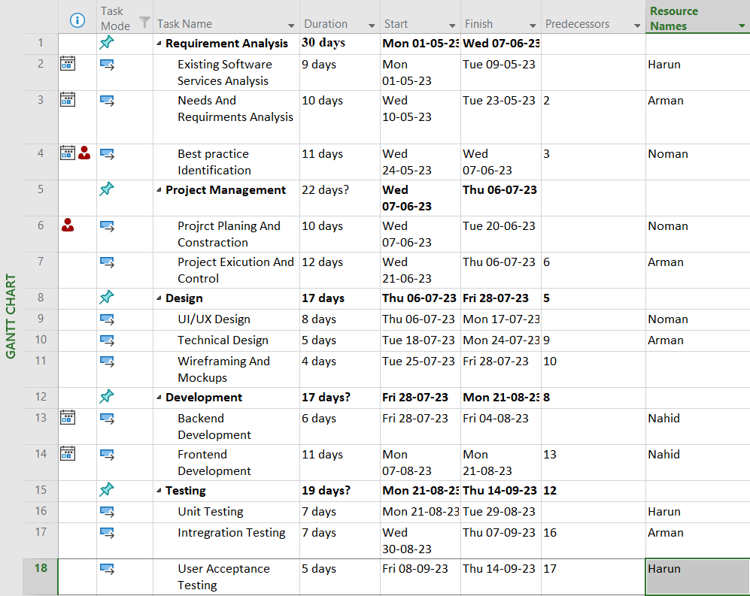

**Figure 7.1: WBS**

**Activity Scheduling and Resource Allocation:**

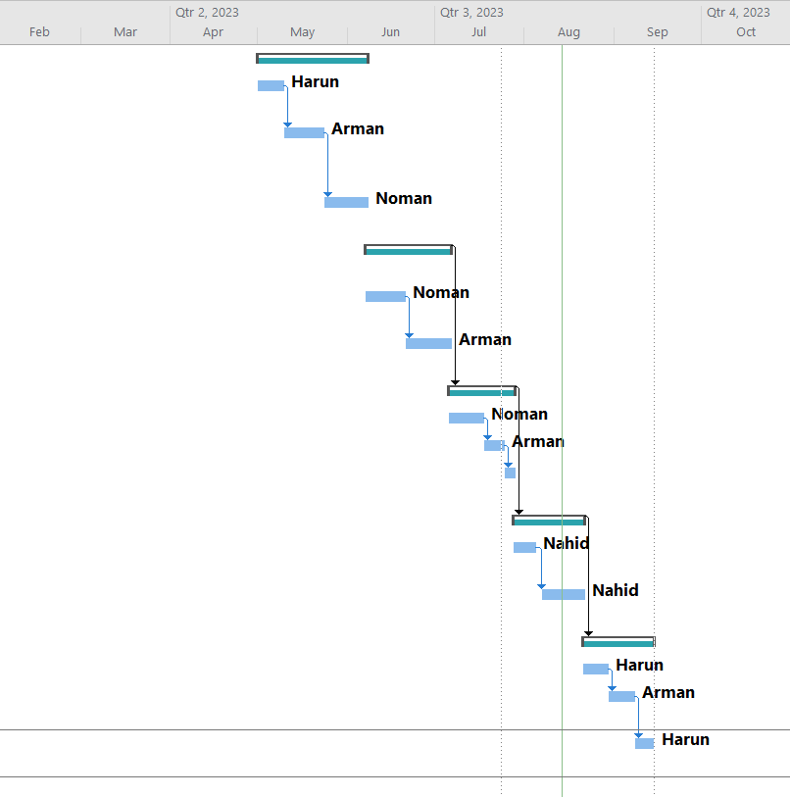

**Figure 8.1: Activity Scheduling-GANTT CHART**

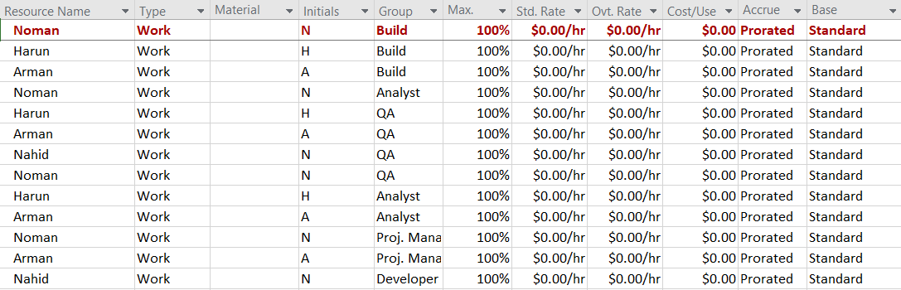

**Figure 8.3: Human Resource Allocation**

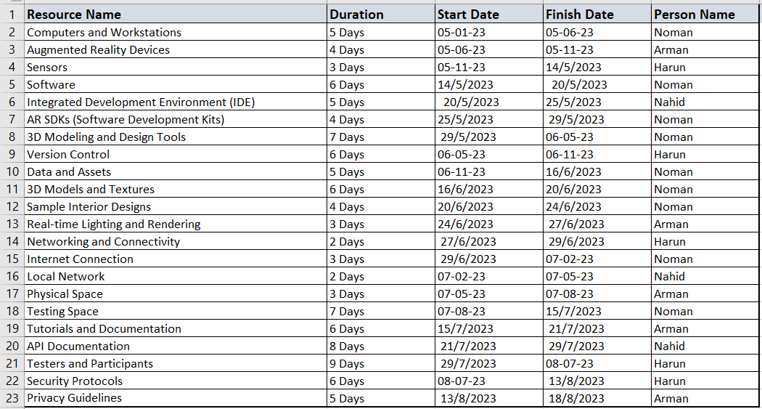

**Figure 8.3: Environment Resource Allocation**

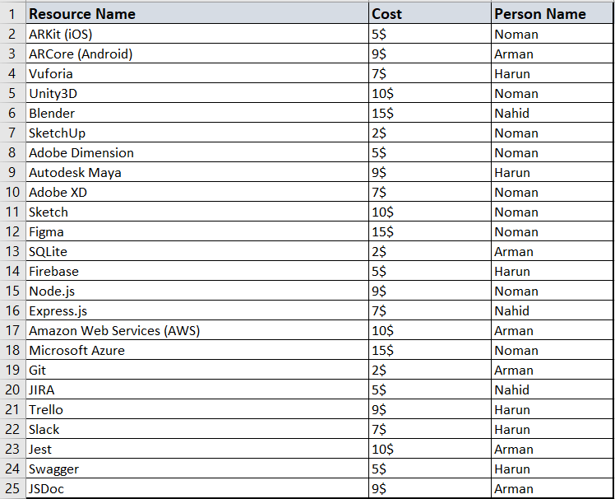

**Figure 8.2: Re-usable Software Resource Allocation**

**Risk Analysis:**

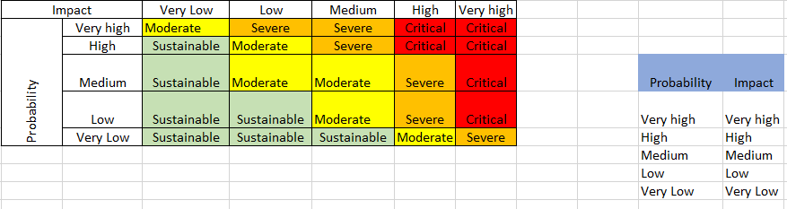

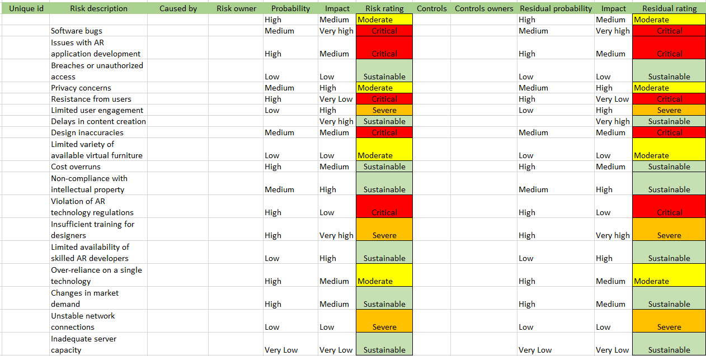**Figure 9.1: Probability impact Matrix**